[Skip to main content](https://lms.alnafi.com/xblock/block-v1:alnafi+DCCS102+2025_DCCS+type@vertical+block@dee2a656206b47d290ab427a0021f509?exam_access=&recheck_access=1&show_bookmark=0&show_title=0&view=student_view" \l "main)

[using SCCM 2012 RC in a LAB - Part 11. Adding the Reporting Services Point role - Configuration Manager 2012 - www.windows-noob.com](https://www.windows-noob.com/forums/topic/4550-using-sccm-2012-rc-in-a-lab-part-11-adding-the-reporting-services-point-role/)

Please read this article and if you prefer you can also try to install it as well.

  Reference <https://www.windows-noob.com/forums/topic/4550-using-sccm-2012-rc-in-a-lab-part-11-adding-the-reporting-services-point-role/>

In [Part 1](https://www.windows-noob.com/forums/index.php?/topic/4422-using-sccm-2012-rc-in-a-lab-part-1-installation/) of this series we got our AD and SCCM servers ready, and then we **installed System Center 2012 Configuration Manager**as a **standalone Primary site**. In [Part 2](https://www.windows-noob.com/forums/index.php?/topic/4427-using-sccm-2012-rc-in-a-lab-part-2-add-sup-and-wds/) we configured the SCCM server further by adding some **Windows Server roles** necessary for the following Configuration Manager 2012 functionality, **Software Update Point (SUP)** and **Operating System Deployment**. In [Part 3](https://www.windows-noob.com/forums/index.php?/topic/4428-using-sccm-2012-rc-in-a-lab-part-3-configuring-discovery-and-boundaries/) we configured the server further by Enabling Discovery methods and creating Boundary's and Boundary Groups. In [Part 4](https://www.windows-noob.com/forums/index.php?/topic/4429-using-sccm-2012-rc-in-a-lab-part-4-configuring-client-settings-and-adding-roles/) we configured **Client Settings**, Added roles and **Distributed the Configmgr Client** to our Computers within the LAB, then in [Part 5](https://www.windows-noob.com/forums/index.php?/topic/4466-using-sccm-2012-rc-in-a-lab-part-5-enable-the-endpoint-protection-role-and-configure-endpoint-protection-settings/) we enabled the **Endpoint Protection Role** and configured **Endpoint Protection** settings and targeted a collection called **All Windows 7 Computers** with these settings and policies.

In [Part 6](https://www.windows-noob.com/forums/index.php?/topic/4467-using-sccm-2012-rc-in-a-lab-part-6-deploying-software-updates/) we configured our SUP further to Deploy software updates to our **All Windows 7 Computers** and **Build Windows 7 X64** collections. In [Part 7](https://www.windows-noob.com/forums/index.php?/topic/4468-using-sccm-2012-rc-in-a-lab-part-7-build-and-capture-windows-7-x64/) we used the **Build and Capture** process to create our Base Windows 7 X64 wim image. In [Part 8](https://www.windows-noob.com/forums/index.php?/topic/4512-using-sccm-2012-rc-in-a-lab-part-8-deploying-windows-7-x64) we created a**USMT 4** package to migrate the users data using hardlinking and then we imported the captured image into ConfigMgr and created a **Deploy Windows 7 X64** task sequence. We created a **Deploy Windows 7 X64** Collection and set some **User Device Affinity collection variables**.

In [Part 9](https://www.windows-noob.com/forums/index.php?/topic/4514-using-sccm-2012-rc-in-a-lab-part-9-adding-an-application-editing-a-deployment-type-copying-the-deploy-task-sequence/) we created an **Application**, and created a **deployment type** for that application to only install if the **Primary User** was True for that device (User Device Affinity), we then copied our Task Sequence (duplicated it), deployed the new Task Sequence, added a computer to the new collection and then PXE booted the computer to the Deployment Menu. In [Part 10](https://www.windows-noob.com/forums/index.php?/topic/4522-using-sccm-2012-rc-in-a-lab-part-10-using-prestart-and-extrafiles-to-get-more-out-of-uda/) we monitored the Deployment process in a lot of detail to how UDA sent state messages and we verified that our application installed on the users Primary Device, in addition we modified our collection variables, and added a prestart command to our boot image to prompt for the SMSTSUdaUsers. Now we will setup the **Reporting Services Point Role and verify that reporting is working.**

**Reporting in Configuration Manager**:-

The following reporting features are new or have changed in System Center 2012 Configuration Manager.

* The reporting point has been deprecated

The Reporting Services point is the only site system role used for reporting in System Center 2012 Configuration Manager. For more information about the Reporting Services point, see the [Reporting Services Point](http://technet.microsoft.com/en-us/library/gg682105.aspx#BKMK_ReportingServicesPoint) section later in this topic.

* Full integration of the Configuration Manager 2007 R2 SQL Server Reporting Services solution

In addition to standard report management, Configuration Manager 2007 R2 introduced support for SQL Server Reporting Services reporting. System Center 2012 Configuration Manager has integrated the Reporting Services solution, added new functionality, and removed standard report management as a reporting solution. For more information about Reporting Services, see the [SQL Server Reporting Services](http://technet.microsoft.com/en-us/library/gg682105.aspx#BKMK_SQLServerReportingServices) section later in this topic.

* Report Builder 2.0 integration

System Center 2012 Configuration Manager uses Microsoft SQL Server 2008 SP1 Reporting Services Report Builder 2.0 as the exclusive authoring and editing tool for both Model and SQL-based reports. Report Builder 2.0 is automatically installed when you create or modify a report for the first time. For more information about Report Builder, see the [Report Builder](http://technet.microsoft.com/en-us/library/gg682105.aspx#BKMK_ReportBuilder) section later in this topic.

* Subscription management

Report subscriptions in SQL Reporting Services enable you to configure the automatic delivery of specified reports by e-mail or to a file share at scheduled intervals.

* Running reports

You can run System Center 2012 Configuration Manager reports in the Configuration Manager console by using **Report Viewer** or you can run reports from a browser by using **Report Manager**. Each method for running reports provides a similar experience.

* Localized reporting

Reports in System Center 2012 Configuration Manager are rendered in the locale of the installed Configuration Manager console. Subscriptions are rendered in the locale that SQL Server Reporting Services is installed. When you author a report, you can specify the assembly and expression.

Reporting in System Center 2012 Configuration Manager provides a set of tools and resources that help you use the advanced reporting capabilities of SQL Server Reporting Services and the rich authoring experience that Microsoft SQL Server 2008 with Service Pack 1 (SP1) Reporting Services Report Builder 2.0 provides. Reporting helps you to gather, organize, and present information about users, hardware and software inventory, software updates, applications, site status, and other Configuration Manager operations in your organization. **Reporting provides you with a number of predefined reports** that you can use as is or that you can modify to meet your needs, or **you can create custom reports**.

The following topics on Technet help you to manage reporting in System Center 2012 Configuration Manager:

* [Introduction to Reporting in Configuration Manager](http://technet.microsoft.com/en-us/library/gg682105.aspx)
* [Planning for Reporting in Configuration Manager](http://technet.microsoft.com/en-us/library/gg712693.aspx)
* [Configuring Reporting in Configuration Manager](http://technet.microsoft.com/en-us/library/gg712698.aspx)
* [Operations and Maintenance for Reporting in Configuration Manager](http://technet.microsoft.com/en-us/library/gg712299.aspx)
* [Security and Privacy for Reporting in Configuration Manager](http://technet.microsoft.com/en-us/library/gg682016.aspx)
* [Technical Reference for Reporting in Configuration Manager](http://technet.microsoft.com/en-us/library/gg682170.aspx)

**Step 1. Install the Reporting Services Point Role**

***Perform the following on your SCCM 2012 server as SMSadmin.***

In the ConfigMgr console, click on **Administration**, Site Configuration, **Servers and Site System Roles**, right click on our server and choose **Add Site System Roles**

[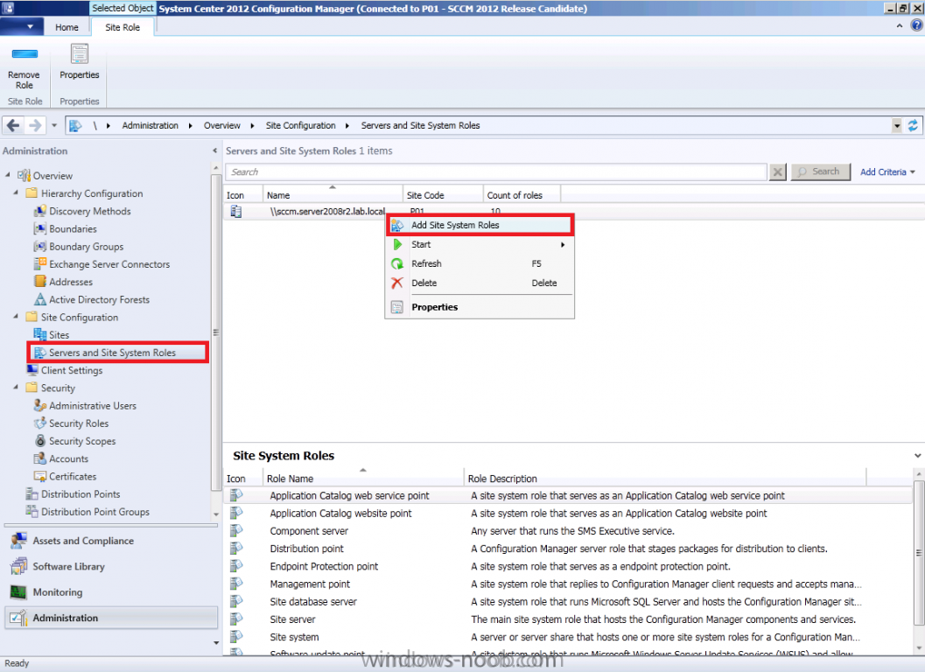](https://www.windows-noob.com/forums/uploads/monthly_11_2011/post-1-0-38598800-1321619236.png)

when the **Add site system roles wizard** appears click next and select **Reporting Services Point** from the list of available choices

[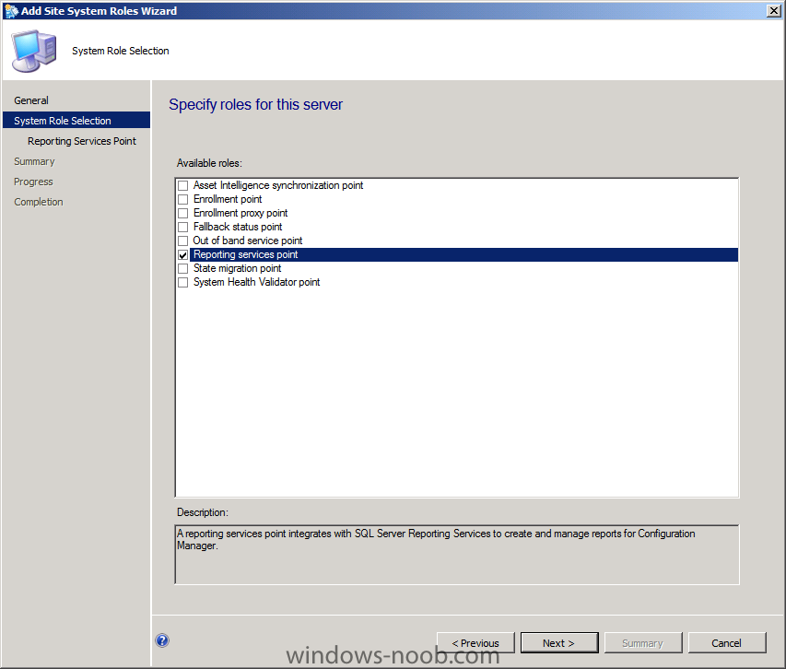](https://www.windows-noob.com/forums/uploads/monthly_11_2011/post-1-0-40502500-1321619439.png)

you'll be asked to specify some **Reporting Services settings**, click on **Verify** beside database name

[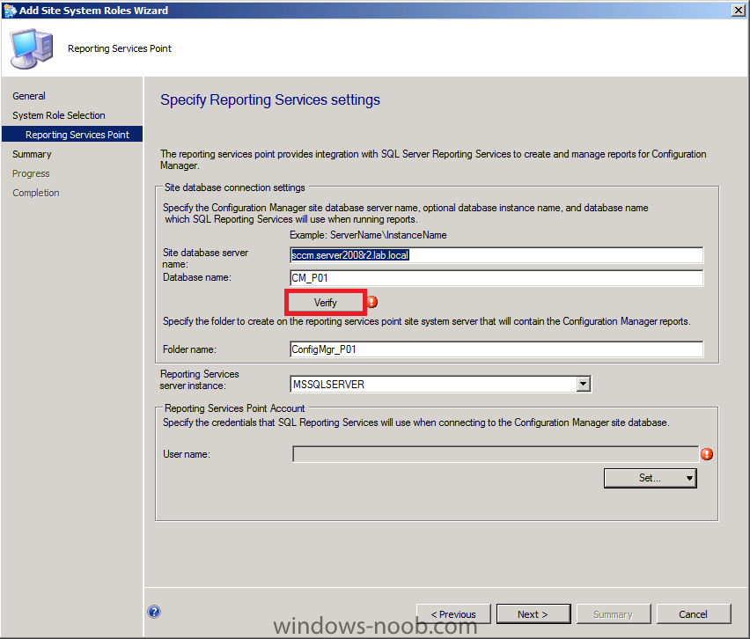](https://www.windows-noob.com/forums/uploads/monthly_11_2011/post-1-0-28548400-1321619567.png)

if all goes well it will be listed as **Successfully Verified**, now we need to configure a **Reporting Services Point Account**, and we will use the Active Directory User (called **ReportsUser**) which we created in [Part 1](https://www.windows-noob.com/forums/index.php?/topic/4422-using-sccm-2012-rc-in-a-lab-part-1-installation/) of this series in Active Directory Users and Computers.

* [ReportsUser](https://www.windows-noob.com/forums/index.php?/topic/4422-using-sccm-2012-rc-in-a-lab-part-1-installation/), a domain user for reporting services.

so for **User Name** click on the **Set** drop down menu and select **New Account**

[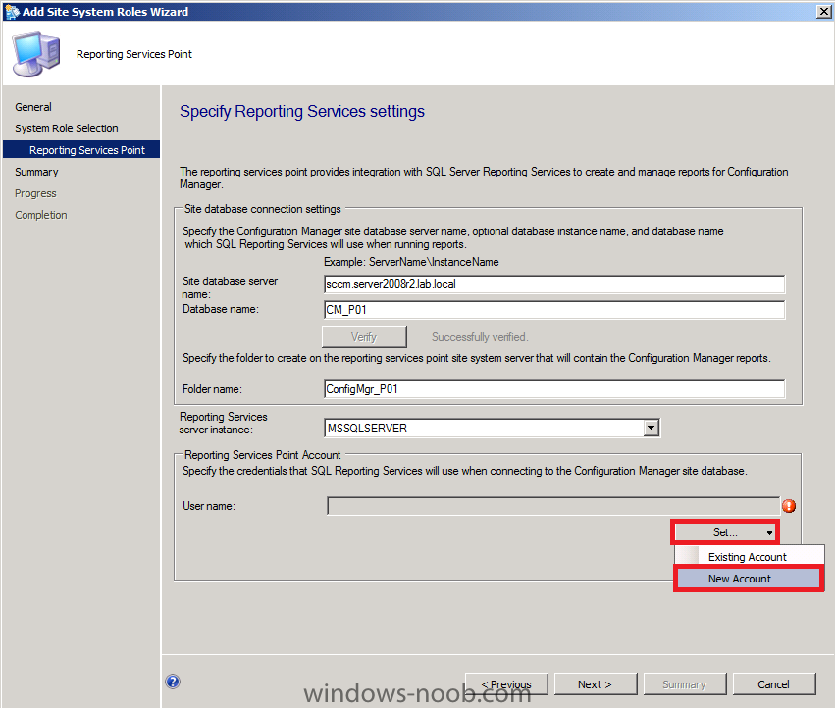](https://www.windows-noob.com/forums/uploads/monthly_11_2011/post-1-0-56923100-1321619863.png)

when prompted for **Windows User Account**, enter the credentials of your ReportsUser account, you can use **Browse** to easily find the user in Active Directory. The specified Windows user account and password is encrypted and stored in the Reporting Services database.

**Note: Reporting Services retrieves the data for reports from the site database using this account and password.**

**Tip: When installing the Reporting Service Point role, you do not have the ability to 'verify' the Reports user you specify, so the user may not even exist in AD. Therefore, you should browse AD when searching for the user.**

[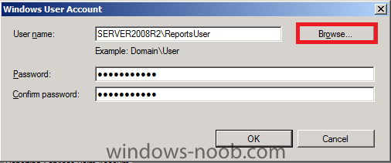](https://www.windows-noob.com/forums/uploads/monthly_11_2011/post-1-0-97636600-1321620160.png)

click next to install Reporting Services

[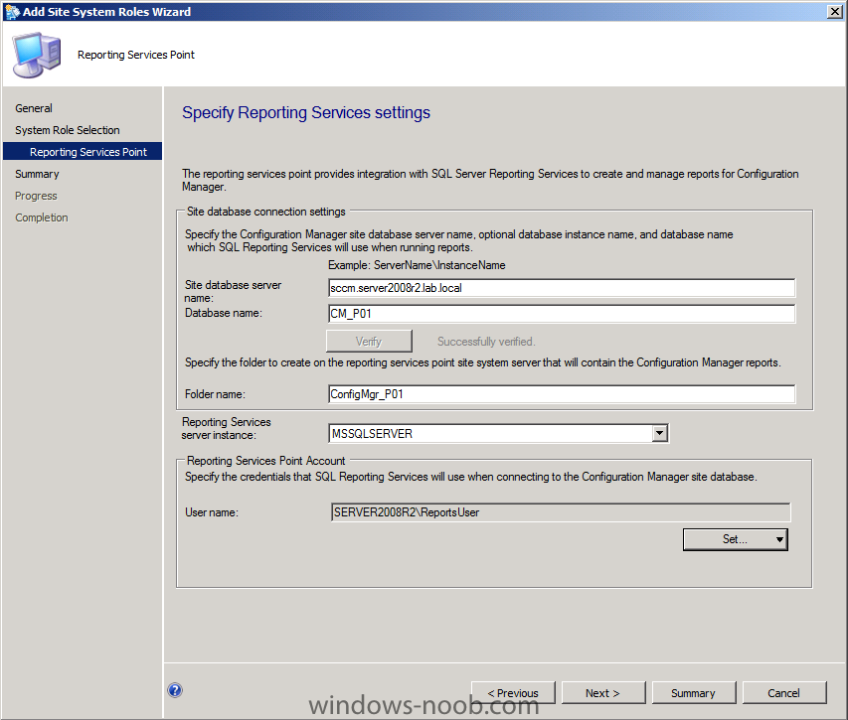](https://www.windows-noob.com/forums/uploads/monthly_11_2011/post-1-0-84561200-1321620238.png)

click next at the summary and review the completion screen.

[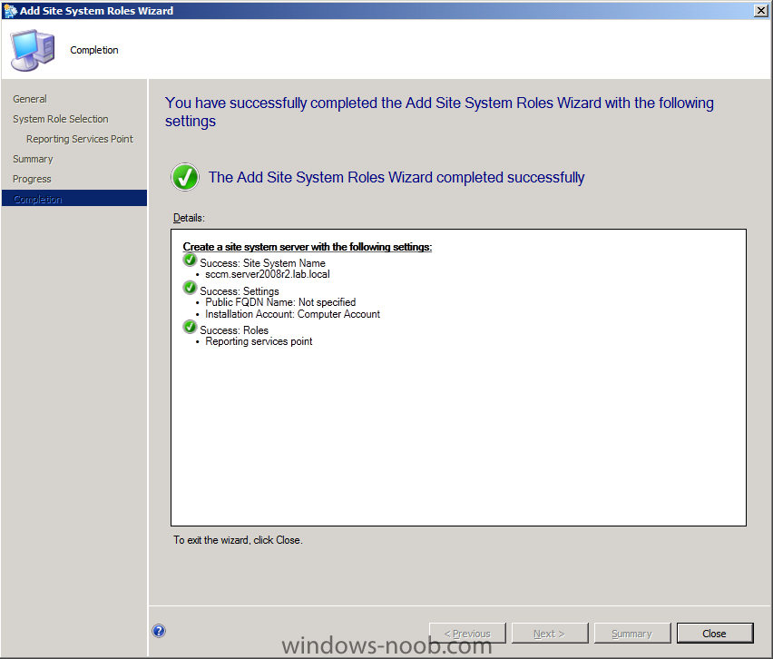](https://www.windows-noob.com/forums/uploads/monthly_11_2011/post-1-0-43373300-1321620301.png)

**Tip: you can verify that the role installs successfully by monitoring the SMS_SRS_REPORTING_POINT log in Component Status, Monitoring. Look for Message ID 1015 which indicates that the Reporting Services point was successfully installed.**

[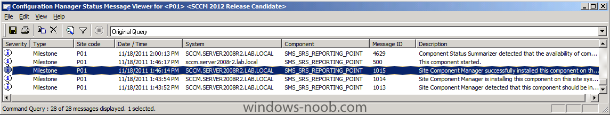](https://www.windows-noob.com/forums/uploads/monthly_11_2011/post-1-0-83227700-1321645570.png)

In addition you can verify by checking the following Log on your server, **SRSRP.LOG** located in D:\Program Files\Microsoft Configuration Manager\Logs, look for a line which reads

    Quote**Successfully checked that the SRS web service is healthy on server**

[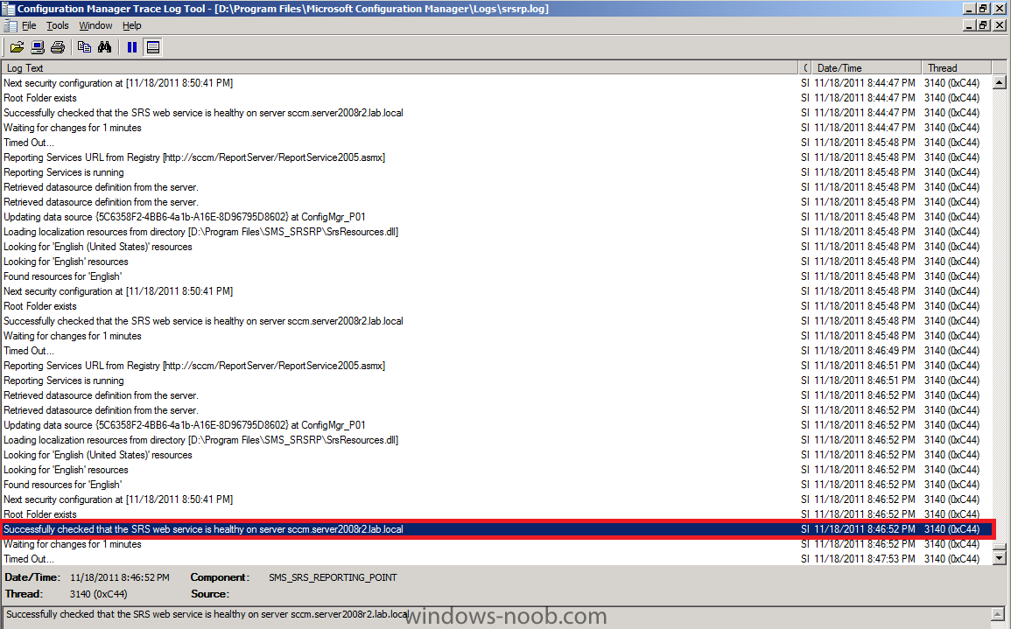](https://www.windows-noob.com/forums/uploads/monthly_11_2011/post-1-0-67591400-1321645862.png)

You should also inspect the **SRSRPSetup.log** file for the following line, **Installation was Successful**.

**Step 2. Configure Reporting**

***Perform the following on your SCCM 2012 server as SMSadmin.***

Now that the Reporting Services Point role is installed we need to do some configuration before we can view reports. In the **Monitoring** Space of ConfigMgr console click on **Reports** it will list 0 items.

[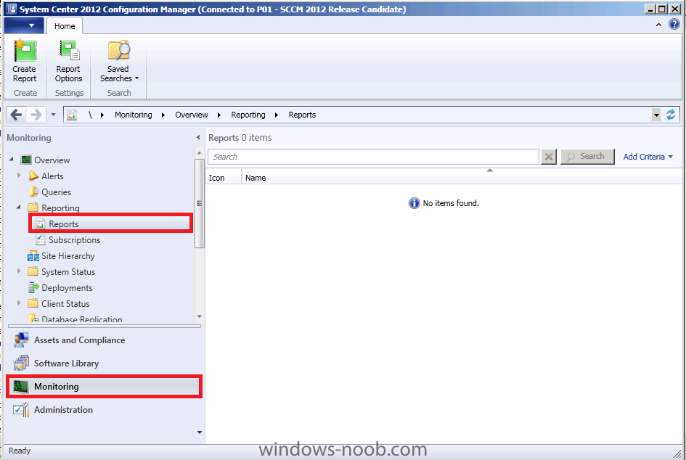](https://www.windows-noob.com/forums/uploads/monthly_11_2011/post-1-0-76757100-1321624719.png)

On your ConfigMgr server, click on the start menu and right click on **Internet Explorer**, choose **Run As Administrator**, answer **Yes** to the UAC prompt.

[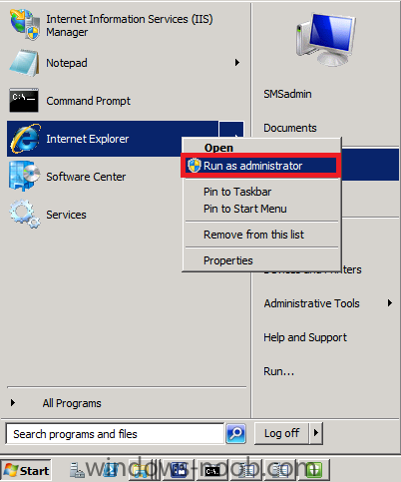](https://www.windows-noob.com/forums/uploads/monthly_11_2011/post-1-0-70495000-1321624942.png)

enter the following URL [**http://sccm.server20...b.local/Reports**](http://sccm.server2008r2.lab.local/Reports) obviously replace your server FQDN in the URL.

[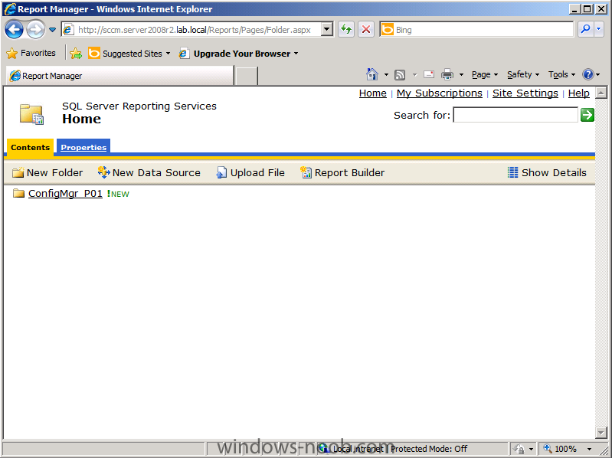](https://www.windows-noob.com/forums/uploads/monthly_11_2011/post-1-0-17012600-1321625640.png)

click on the **Properties** Tab followed by **New Role Assignment**

[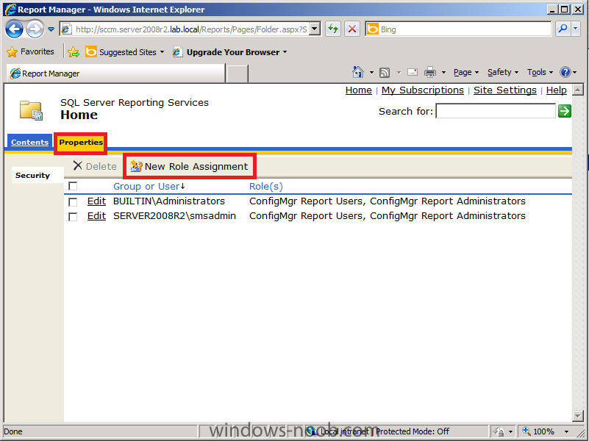](https://www.windows-noob.com/forums/uploads/monthly_11_2011/post-1-0-16722600-1321625738.png)

In **Group or Username** enter **Server2008R2ReportsUser** and give the user the permissions you want

[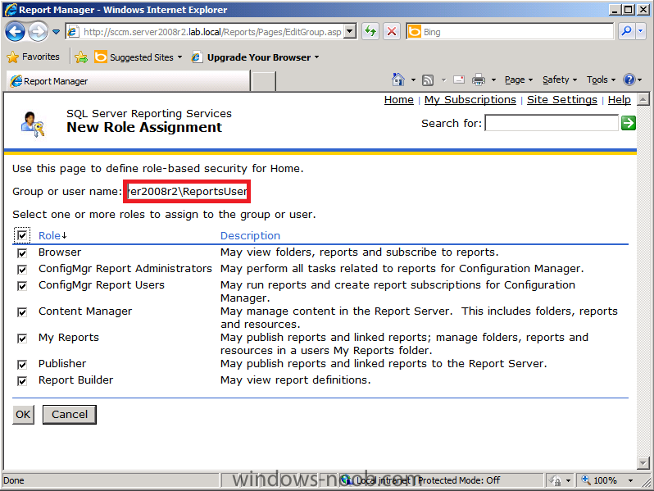](https://www.windows-noob.com/forums/uploads/monthly_11_2011/post-1-0-78856400-1321625980.png)

now we can see that the **ReportsUser** has all reporting roles, and as this is a LAB we should verify that SMSadmin has the rights to do everything, select the SMSadmin user and choose Edit,

[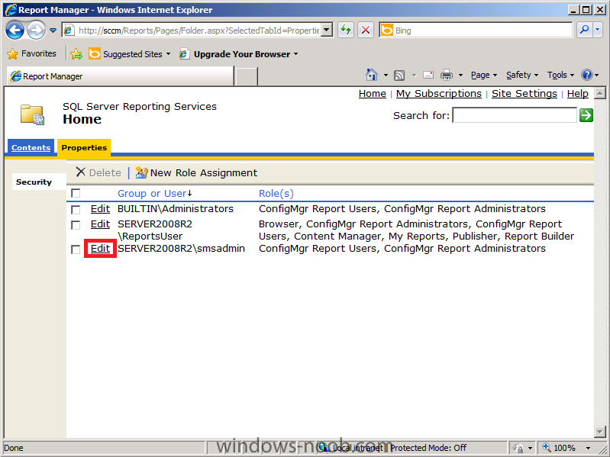](https://www.windows-noob.com/forums/uploads/monthly_11_2011/post-1-0-13834200-1321633903.png)

click the **Role** checkbox so that we get all roles, and then click **Apply**, after editing both users we want them to have all permissions for Reporting services,

**Tip: This is a LAB so it's ok to configure Reporting this way, in production you would want to be more specific about what permissions users are granted.**

[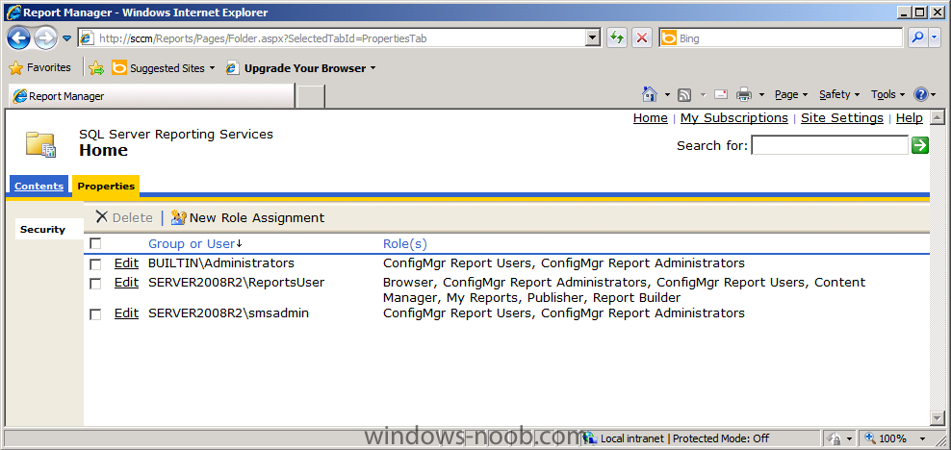](https://www.windows-noob.com/forums/uploads/monthly_11_2011/post-1-0-39587300-1321637020.png)

exit from Internet Explorer, and browse Reports within ConfigMgr again, the Reports are listed and ready to be used, note that they are sorted by Category (and also below Reports are Category Folders)

[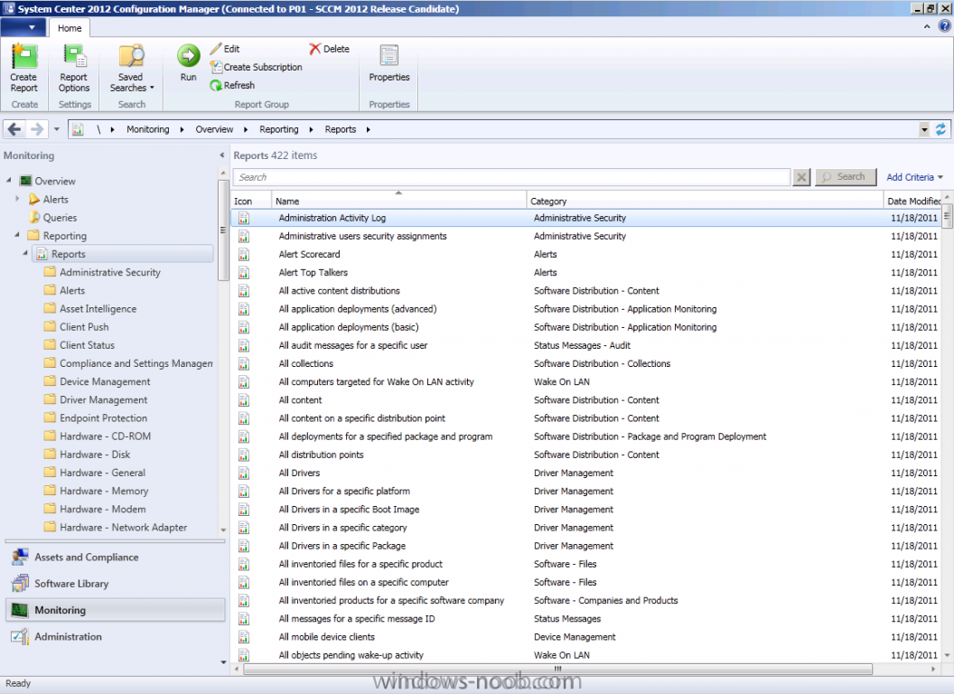](https://www.windows-noob.com/forums/uploads/monthly_11_2011/post-1-0-97045200-1321634640.png)

**Step 3. Viewing some Reports**

***Perform the following on your SCCM 2012 server as SMSadmin.***

In the ConfigMgr console, expand reports, Select the **All Collections** report, right click it, choose **Run**,

[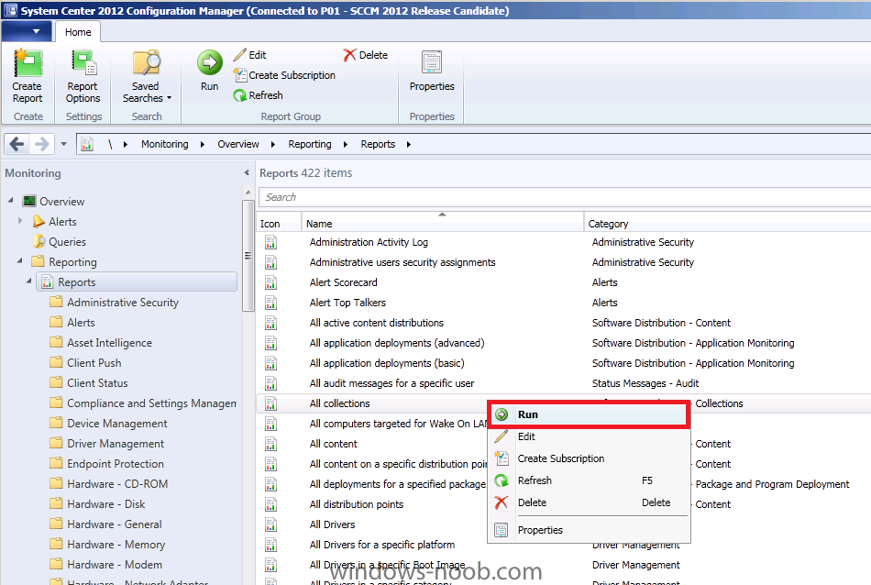](https://www.windows-noob.com/forums/uploads/monthly_11_2011/post-1-0-09014700-1321634802.png)

a list of collections appears in the **Report Viewer**, you can drill down further into the report by clicking on **All Systems**

[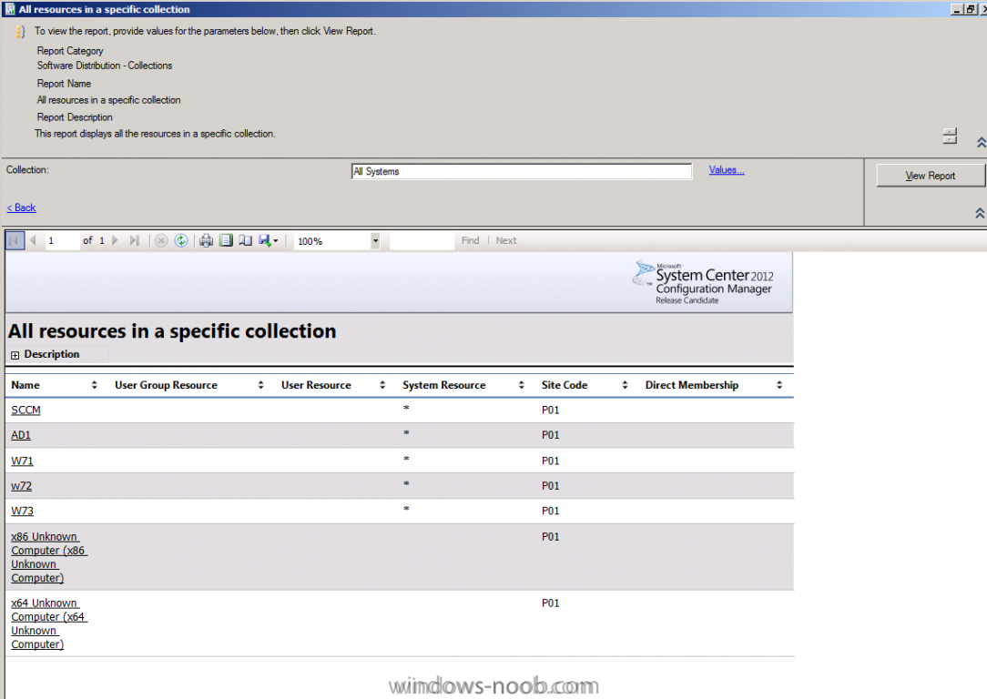](https://www.windows-noob.com/forums/uploads/monthly_11_2011/post-1-0-34790000-1321635916.png)

on one of your **Windows 7 Client Computers**, login as **ReportsUser** and start Internet Explorer, browse to http:\sccm.server2008r2.lab.localreports and select a report from the ConfigMgr_P01 database

**Tip: if the ConfigMgr_P01 database doesn't appear as a temporary measure you can add the ReportsUser to the Local Administrators group on your SCCM server, that's ok in a LAB, in production you'll want to configure your security accordingly and create Groups for Report Readers and Report Administrators.**

[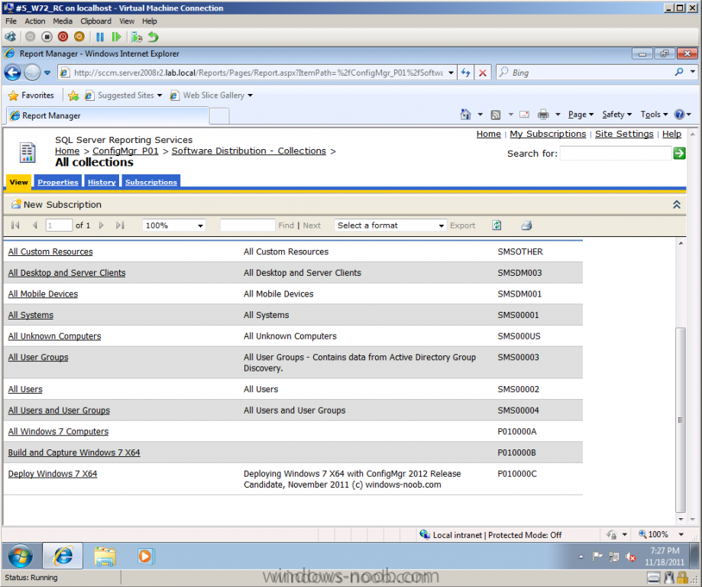](https://www.windows-noob.com/forums/uploads/monthly_11_2011/post-1-0-02318100-1321640988.png)

Thats it ! **Reporting Services Point** is installed and in our next part we will look at our Endpoint Protection reports and monitor it real time both on the Server and Clients.

* [Quote](https://www.windows-noob.com/forums/topic/4550-using-sccm-2012-rc-in-a-lab-part-11-adding-the-reporting-services-point-role/)